120th Convention of the Episcopal Church of Utah
Report for Camp Tuttle
This summer at Camp Tuttle, the Spirit flowed through our theme, Streams of Living Water. Campers, families, staff, and visiting groups found new ways to encounter the Divine in creation, build meaningful community, and deepen their faith while having unforgettable adventures in our mountain oasis
Summer Camps That Inspire and Challenge
We welcomed 214 children and youth from 2nd through 12th grade to four week-long summer camps filled with fun, faith, and discovery. Of those, 62 were only able to attend thanks to generous scholarship donations.
Campers explored age-appropriate adventures—river rafting, backpacking, night games, candle making, high and low ropes course challenges, rock climbing, lake time, mountain biking, and plenty of Nuke ’em, a camp favorite! These challenges fostered resilience, teamwork, and joy while sparking lifelong friendships.

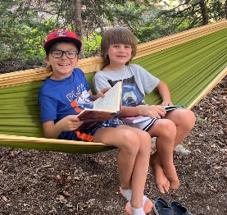
Faith formation was woven throughout camp life. Campers learned to notice God’s presence by “hunting for glimmers” in nature, praying in color, and reflecting on the streams of living water in their lives. Evening singing and Nightwatch services became powerful moments of connection, often lifting the voices of even the quietest campers.

Rich Worship and Spiritual Support
Our chaplains played a vital role in nurturing faith. Each received the new Camp Tuttle Chaplain Handbook, along with fresh resource materials, to inspire Morning Watch and Night Watch services. Their diverse approaches offered campers and staff meaningful ways to pray, reflect, and experience God’s love throughout the day. “I saw more than one glimmer today!” (Camper)

Welcoming Families and the Wider Community
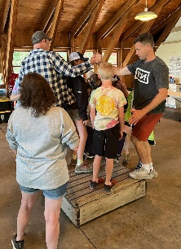
Staff Growth and Innovative Training
In addition, the Vitality and Youth programs held three weekend retreats and a day-long workshop, strengthening young people’s connections and offering leadership opportunities to both seasoned campers and newcomers alike.

Two family camps welcomed parents, children, and grandparents to share outdoor adventures, worship, and laughter together—now a beloved tradition for many in our Diocese. Beyond that, Camp Tuttle hosted nine outside groups, including a wedding celebration, a family reunion, school groups exploring the challenge courses, and a Live Action Role Playing (LARP) event. These gatherings affirmed Camp Tuttle’s role as a vibrant hub for celebration, community, and spiritual renewal.
“This is the wedding I have always dreamed of, thank you!” (Bride)

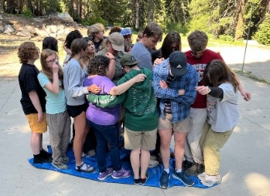
Staff remain the heart of Camp Tuttle. Training this year included a session with the Wasatch Mountain Institute, equipping counselors with new tools for exploring nature with kids and adding fresh games to camp life. Counselors modeled service and care in every setting—from leading outdoor adventures to sharing late-night heart-to-heart conversations.
Facilities Renewal and Progress
Camp facilities saw meaningful updates this year: new countertops and lower kitchen cabinets, along with an updated infirmary counter and sink. These upgrades support both safety and hospitality.
A long-awaited milestone also arrived—the log framing for our new camp sign is complete, with sign installation scheduled for early spring. Soon, all who arrive will be welcomed by a sign that reflects the beauty and spirit of Camp Tuttle.
Challenges and Opportunities for Support
Like any camp of its age, Tuttle faces ongoing needs. Major projects include replacing the computer system that manages the water supply, and addressing rot in lodge supports. Smaller but important updates include adding sand to the Nuke ’em court, laying new gravel near the pavilion, and repainting parts of the lodge and several cabins.
The best ways to support Camp Tuttle are by joining workdays like Labor of Love in June and contributing to the scholarship fund. Volunteer hours save significant resources, while scholarships ensure every child who wishes to attend camp has the opportunity to do so.
“This is a second home for our family.” (Labor of Love participant)
A Flowing Future of Ministry
From the joy of Streams of Living Water to the laughter of friends around a campfire, Camp Tuttle remains a sacred space where lives are changed. Campers return home with stronger friendships and a deep attachment to camp. Families leave with memories of laughter and love. Staff grow as leaders and caretakers of the next generation.
The summer of 2025 was more than adventure—it was about building resilience, fostering community, and recognizing where the Divine shows up. Whether a child sang boldly for the first time, a teen conquered the high ropes, a family reconnected, or an outside group found renewal in the mountains, God’s living water flowed abundantly.
Looking ahead, Camp Tuttle remains committed to being a place that is welcoming, diverse, and caring. With your continued prayers and support, the streams that began here will keep flowing—nourishing hearts, deepening faith, and bringing joy to all who encounter this sacred space.